7. Scenario: You are working as a data analyst for an e-commerce company. You have been given

a dataset containing information about customer orders, stored in a Pandas DataFrame named

order_data. The DataFrame has columns for customer ID, order date, product name, and order

quantity. Your task is to analyze the data and answer specific questions about the orders.

Question: Using Pandas DataFrame operations, how would you find the following information

from the order_data DataFrame:

1. The total number of orders made by each customer.

2. The average order quantity for each product.

3. The earliest and latest order dates in the dataset.

**Code:**

**import pandas as pd**

df = pd.read_csv(r"C:\Users\vara prasad\OneDrive\Documents\customer_orders 7th.csv")

df['Order Date'] = pd.to_datetime(df['Order Date'])

total_orders_per_customer = df.groupby('Customer ID').size()

average_quantity_per_product = df.groupby('Product Name')['Order Quantity'].mean()

earliest_order_date = df['Order Date'].min()

latest_order_date = df['Order Date'].max()

print("1. Total number of orders per customer:")

print(total_orders_per_customer)

print("\n2. Average order quantity per product:")

print(average_quantity_per_product)

print("\n3. Earliest and latest order dates:")

print(f"Earliest: {earliest_order_date.date()}")

print(f"Latest: {latest_order_date.date()}")

**output:**

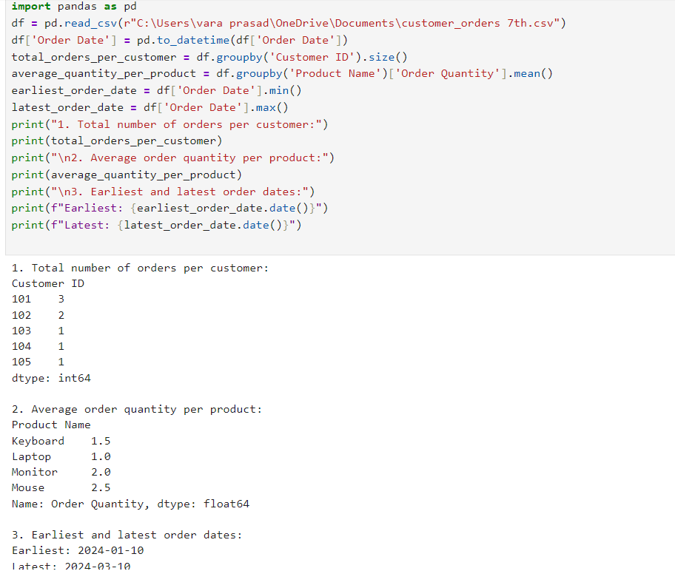

**Dataset:**

|  |  |  |  |  |
| --- | --- | --- | --- | --- |
| Customer ID | Order Date | Product Name | Order Quantity | |
| 101 | ######## | Laptop | 1 |  |
| 102 | ######## | Mouse | 2 |  |
| 101 | ######## | Keyboard | 1 |  |
| 103 | ######## | Laptop | 1 |  |
| 102 | ######## | Mouse | 3 |  |
| 104 | ######## | Monitor | 2 |  |
| 101 | ######## | Laptop | 1 |  |
| 105 | ######## | Keyboard | 2 |  |